 |  | 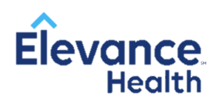
 | JOIN OUR GROWING INTERN PRIOR AUTHORIZATION TEAM!
 |  | - We are hiring at elevance health!  - (formerly anthem, inc) |  |  | BENEFITS:  - Work from home  - Flexible 20 hr/week schedule (Open 24 hours/7 days a week)  - Competitive hourly pay  - Supportive team of medical directors, pharmacists, and interns  - Exposure to multiple areas within a PBM
Join Elevance Health and make an impact on day one.
Here, you can count on cross-functional collaboration that uses the strength of our diversity to create innovation breakthroughs for our members.

 | Our intern team has direct experience with prior authorization processes, drug utilization reviews, and supports cost effective formulary decisions.
Please apply at careers.elevancehealth.com   
Job ID: JR9747, JR17877, JR17874, JR17881, JR17843, JR17846
*More positions to be posted soon

